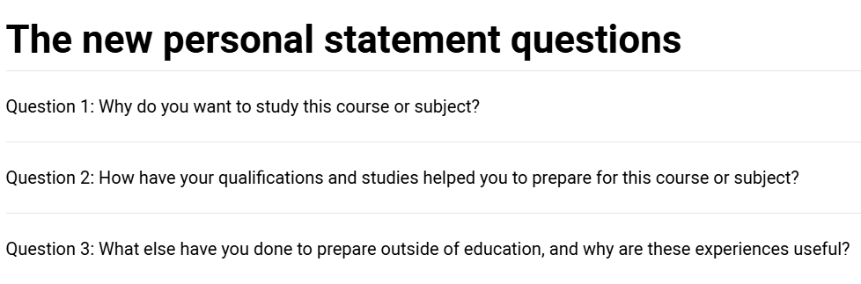
Question 1: Why do you want to study this course or subject?
This is your opportunity to showcase your passion and knowledge of your chosen subject area and to demonstrate to universities and colleges why it’s a good fit for you and your future ambitions.
Examples of what you might talk about here are:
- Your motivations for studying this course(s)
Have you been inspired by a key role model or moment in your life? Maybe it’s a subject you love and want to pursue further. We’re all driven by something and it’s important to talk about how yours has led you to this course or subject area.
- Your knowledge of this subject area and interests
Perhaps there’s a particular subject area you’ve researched and can’t wait to learn more about. A book or subject expert doing great things that have sparked your interest? Universities and colleges want to see you have done your research so they can be confident this is something you will enjoy and excel in. This is a great place to highlight super-curricular activities as evidence of curiosity and interest in the subject outside of the classroom.
- Your future plans and why this is a good fit for you
If you already have a particular profession in mind you could talk about how you’ll use this to launch your career. If you don’t, think about what’s important to you and your future, and how the knowledge gained from your chosen course(s) will help you achieve this.
Here are some more examples for this section:
- Personal life experiences e.g. being a carer, the environment where you grew up or lived, an inspirational friend, colleague or family member, a book you read, a news article or blog/vlog, a YouTube video, a podcast, a show you saw, subject tasters
- Understanding of the area and the qualities you might need to succeed in it – research into the course/area

Question 2: How have your qualifications and studies helped you prepare for this course or subject?
This is your chance to shout about the relevant or transferable skills you’ve gained from your formal education and highlight your understanding of how they will help you succeed in this subject area.
Examples of what you might talk about here are:
- How your studies or training relate to your chosen course(s) or subject area
This could be current or previous studies within a school, college, training provider, or even a short online university course – any form of formal education. The main thing here is to focus on what’s most recent and relevant to your chosen course(s). If you are no longer in full-time education, use section three to talk about your experiences since leaving.
- What relevant or transferable skills you have that make you a great candidate
Maybe there are a couple of subjects that have helped you develop a core set of skills required for your chosen course(s). Or, a particular module that helped you understand where your interests and strengths lie.
- Any relevant educational achievements
Universities and colleges will see your grades elsewhere on your application so don’t waste time talking about these. Consider accomplishments like winning a school or national competition, serving as a student ambassador or team captain, or landing the lead role in a play.
Here are some more examples for this section:
- Specific modules or topics
- Essays or projects that explore a particular view point or technique
- EPQ – Extended Project Qualification
- School, local, or national competitions e.g. UKMT
- Private lessons and qualifications e.g. music, stage school or sports if relevant to the course
- Tutoring or mentoring
- Online courses leading to a qualification
Question 3: What else have you done to prepare outside of education, and why are these experiences useful?
This is your chance to talk about any other activities you have undertaken outside of your formal education or personal experiences which further demonstrate your suitability for the course. This section is likely to be highly personal to you and anything you do include should reflect on why you’re including it.
Examples of what you might talk about here are:
- Work experience, employment, or volunteering
Whether it’s in-person work experience at your local school or virtual work experience through Springpod, or volunteering at a dog shelter, the key thing here is for you to reflect on your experiences and the skills gained relevant to your chosen course.
- Personal life experiences or responsibilities
Is there a situation you’ve personally overcome that has influenced your decision? Are there responsibilities such as caring for a family member that has helped you develop essential qualities for the course like resilience and empathy?
- Hobbies and any extracurricular or outreach activities
Think sports, reading, community work, summer schools – any activities outside of your studies that help further showcase why you’d make a great student.
- Achievements outside of school or college
This could be a position of responsibility such as captain for your local club, a musical achievement, competition you won, or a qualification you’ve attained outside of the classroom.
- Post-education activities
If you’re no longer in full-time education, it’s a good idea to detail what you’ve been doing since and how this has equipped you with the skills and qualities for your desired course(s).
Here are some more examples for this section:
- Extra and super-curriculars, Volunteering, Personal life experiences e.g. caring for a family member, overcoming a challenge, Young enterprise, Work experience, Job/employment – part-time or full-time, Work-based learning/CPD, Shadowing, Online learning activities e.g. Springpod, MOOCs etc., Tutoring, Trips and visits (online or in person) e.g. Museums, exhibitions, galleries, sites of historic interest, relevant sites connected to your course e.g. magistrate courts for law etc., Podcasts, TED talks, documentaries etc., Duke of Edinburgh/Duke of York awards

